Minimalism Video and Questions

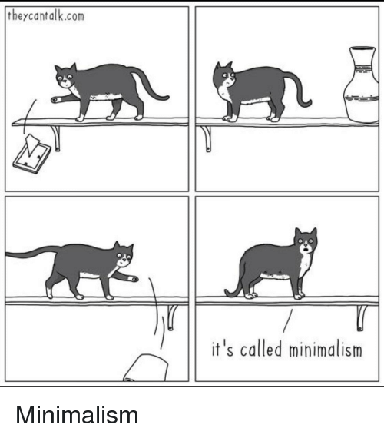
Video link: https://www.youtube.com/watch?v=jrf_dMnatW0

Instructions:
In class we have been talking about money. In connection to that, here is a video about minimalism. Please watch it and then answer the following questions. Submit your answers through Edmodo.

- Write down 20 unknown words and expressions and their Hungarian meaning.
- What is minimalism?
- What do some minimalists do?
- Who are Josh and Ryan? What did they do?
- Do you think you could be a minimalist? Why or why not?

